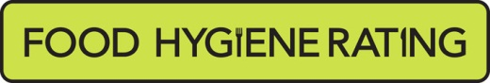
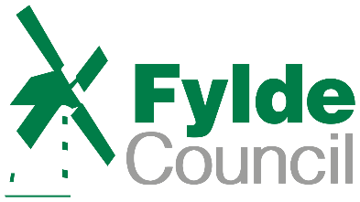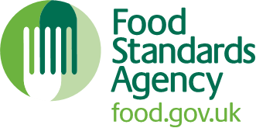

Food Hygiene Rating Scheme: Request for a re-visit

Notes for businesses:
- As the food business operator of the establishment you have a right to request a re-visit for the purposes of a new food hygiene rating if you have taken action to rectify the non-compliances identified at the time of inspection.
- There is a fee of £194 to request a re-visit for re-scoring purposes. Where Councils charge a fee, there is no limit on the number of requests you may make. You should be aware that such a request does not preclude enforcement action where this may be deemed necessary.
- You must provide details of the improvements made with your request, including supporting evidence in writing where appropriate.
- If Fylde Council considers that you have provided sufficient evidence that the required improvements have been made and paid the appropriate fee, an unannounced visit will be made within 3 months (if you were only required to make permanent structural improvements or repairs or to upgrade equipment, Fylde Council can choose to carry out the requested re-visit sooner than this).
- The local authority officer will give you a ‘new’ food hygiene rating based on the level of compliance that is found at the time of the re-visit - you should be aware that your rating could go up, down or remain the same.
- To make a request for a revisit, please use the form below and return it to the food safety officer from your local authority – contact details are provided with the written notification of your food hygiene rating.

Business details
Food business operator/proprietor | Click or tap here to enter text.
Business name | Click or tap here to enter text.
Business addresses | Click or tap here to enter text.
Business tel. number | Click or tap here to enter text.
Business email | Click or tap here to enter text.

Inspection details
Date of inspection | Click or tap here to enter text.
Food hygiene rating given | Click or tap here to enter text.

Action taken
Please describe the remedial action you have taken with reference to the issues identified in the inspection letter/report provided to you by your local authority with your score:
Compliance with food hygiene and safety procedures | Click or tap here to enter text.
Compliance with structural requirements | Click or tap here to enter text.
Confidence in management/control procedures | Click or tap here to enter text.

Please provide any other supplementary evidence (e.g. photographs, invoices, copies of relevant HACCP documentation etc.). | Click or tap here to enter text.

Signature

Name - in capitals | Click or tap here to enter text.
Position | Click or tap here to enter text.
Date | Click or tap here to enter text.
Please now return this form to: commercial@fylde.gov.uk

