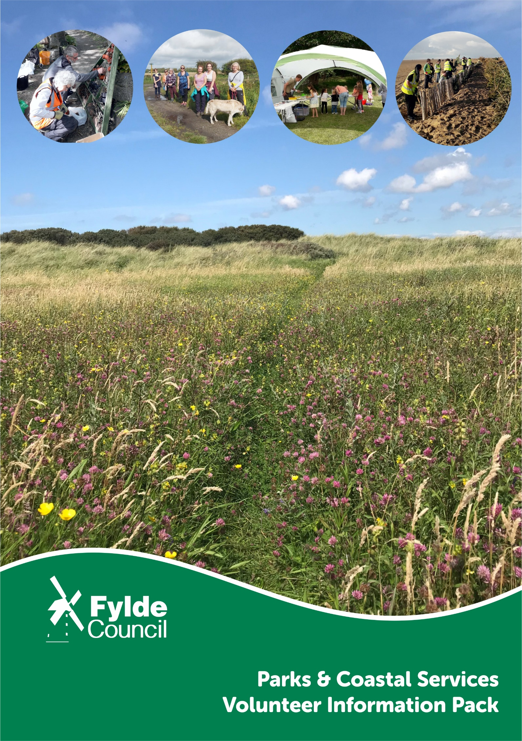

Value of Volunteering
Volunteering has made an immeasurable contribution to local communities, organisations and individuals throughout the borough and country. Today’s volunteers are active, dynamic and creative individuals with the skills, desire and time to accomplish a wide variety of worthwhile tasks.
Why Volunteer for Fylde?
The stewardship of the Fylde’s parks and coastal areas is very important to Fylde Council and the local community. Our parks, beaches and rural areas have a longstanding history of winning national awards and accreditations. These spaces are there for everyone to enjoy thanks to those who have served over numerous years to preserve, protect and improve them. Volunteering is beneficial in providing the local community with opportunities to gain a variety of experience and skills, whilst meeting and working with like-minded people and keeping fit.
Volunteer Activities
We appreciate that volunteers have a huge range of skills to offer. The abilities, experience and expertise of volunteers is limitless and they are a significant, welcome resource. We have a broad range of volunteer activities on offer. Whether you want to undertake practical conservation work, survey some of the UK’s most protected species or work with the public in the delivery of events and environmental education activities, there is something for everyone.
The range of activities you can support:
- Wildlife surveys
- Photography
- Assisting with environmental and historical projects
- Specialist habitat management
- Assisting with estate maintenance
- Assisting with outdoor, public events
- Assisting with environmental education sessions with schools
- Litter picking
Benefits of Volunteering
As a Volunteer with Fylde, you will enjoy a number of benefits including:
- Training, new skills and experiences
- Career enhancement
- Invitations to workshops, presentations and events
- Team building and meeting new friends
- All necessary personal protective equipment (PPE)
- Sense of achievement
- Exercise, enjoyment and being outdoors

What we Require
Anyone over 18 years of age can volunteer. Volunteers must meet the following requirements:
- Completion of a short application form
- Volunteer induction
- Attend relevant training as needed
- Good customer care and communications skills
- Enthusiasm, professionalism and commitment
- Have an interest in environmental management and promotion

Volunteer Recruitment
Once you have submitted your application form, one of our rangers will contact you to arrange an informal meeting to discuss the volunteer role and your interests, you will be offered a taster session(s) on that role. On completion of the taster day(s) all new volunteers will be required complete a half day induction which includes:
- Corporate details on Fylde Council
- Parks and Coast Service structure and introduction to the team
- Background to Fylde’s coast, green spaces and ecological assets
- Fylde Council’s partners and key players
- Summary of existing programmes, sites and projects
- Health and safety policies and procedures
- Signing up to volunteer declaration

Is it right for you?
Volunteering is a two way process. Whilst the council benefits from your time and contribution, it is equally important you gain from your experience with us. You can help us by making sure you chose the right role for you.
It is paramount to us that you enjoy your experience as a volunteer and that you have time to commit to becoming a volunteer. Whilst volunteer roles can evolve over time, it is important to think why you want to volunteer and what you want to do. The following questions may help.
- Have much time do I have to commit?
- Am I willing to participate in necessary training?
- What skills and knowledge can I offer?
- What would I gain by volunteering?
- In what way do I want to volunteer?

Meet the team
The Coast and Conservation Team who sit within Fylde Council’s Parks and Coastal Service is responsible for the training and coordination of volunteers. The team consist of six friendly and experienced staff who work in across the whole of the borough. The team’s responsibilities include: protection, management and maintenance of Fylde’s ecological assets and statutory sites; delivery of practical environmental and conservation projects; uniformed patrols and liaison with visitors to provide reassurance and deter antisocial behavior; delivery of an annual guided walks, events and children’s activities programme; delivery of a formal environmental education programme with schools; management of volunteer programmes aimed at engaging the local community in the management of the environment.

Edward Mooney Fraser Beasley-Monteath
Area Conservation Ranger Area Conservation Ranger

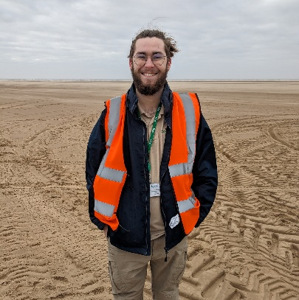

Hilary Salkeld Andrew Mills
Conservation Operative (Fylde Sand Dunes) Area Conservation Ranger (Fylde Sand Dunes)
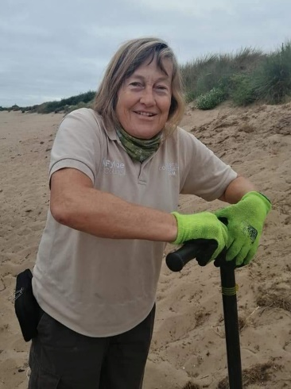
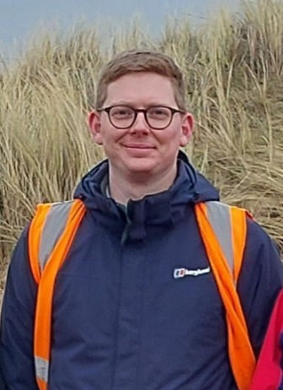

David Tomlinson Julie Vale
Area Conservation Ranger (Beach Patrol) Senior Coast and Conservation Officer

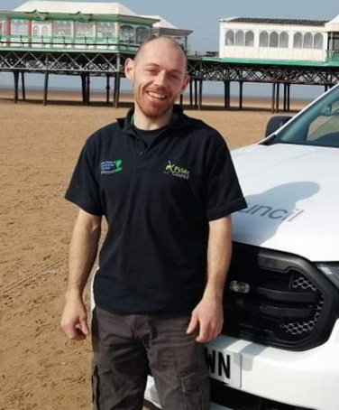

Volunteer Role Descriptions

Volunteer Ranger
The primary role of the Volunteer Ranger will be to support the work carried out by the Council’s Area Conservation Rangers. Therefore, this is a dynamic, exciting and multi-disciplinary role. The scope and geographical focus of the Fylde Ranger Service is broad, therefore flexibility is valued from volunteers in this role. This role will suit those who wish to fully experience modern day rangering and for those who have a keen desire for making a positive contribution to Fylde’s biodiversity and environment.

What will you be doing?
- Practical conservation work on a wide variety of habitats
- Litter picking duties
- Environmental projects on the coast, urban parks and rural areas
- Supporting outdoor events, walks and activities
- Supporting with wildlife surveys
- Working on key sites (Green Drive Woodland, The Crescent Gardens, Hope Street Park) or anywhere in the borough a project or event is taking place

What skills or knowledge do you need?
- Flexibility, adaptability and open mindedness – the right candidate for this role will appreciate the broad and dynamic nature of the role
- A good level of basic fitness would be helpful. This role will include some practical work so may be physically demanding
- Good people and communication skills, positively representing the Council at all times
- Willingness to work outdoors in all weathers
- Basic experience of using hand tools advantageous but not essential
- Driving license and ability to travel advantageous but not compulsory
- Commitment and reliability

Dune Conservation Volunteer
The Fylde Sand Dunes are managed in partnership by Fylde Council and the Wildlife Trust for Lancashire, Manchester and Merseyside as part of the Environment Agency funded Fylde Sand Dunes Project. The project aims to protect and improve the dune network for both wildlife and visitors. Dune Conservation Volunteers support the Fylde Sand Dune Project staff in a wide variety of dune patrols and conservation work.
What you will be doing?
- Dune patrols
- Dune stabilisation work
- Removal of invasive species
- Dune grassland management
- Making small dune wildlife ponds
- Planting of native dune grasses and plants
- Litter picking and removal of fly tipping
- Estate maintenance including path maintenance, installing furniture and fencing

What skills or knowledge do you need?

- Flexibility, adaptability and open mindedness
- A good level of basic fitness would be helpful. This role will include some practical work so may be physically demanding
- Good people and communication skills, positively representing the Council at all times
- Willingness to work outdoors in all weathers
- Basic experience of using hand tools advantageous but not essential
- Driving license advantageous but not compulsory
- Commitment and reliability

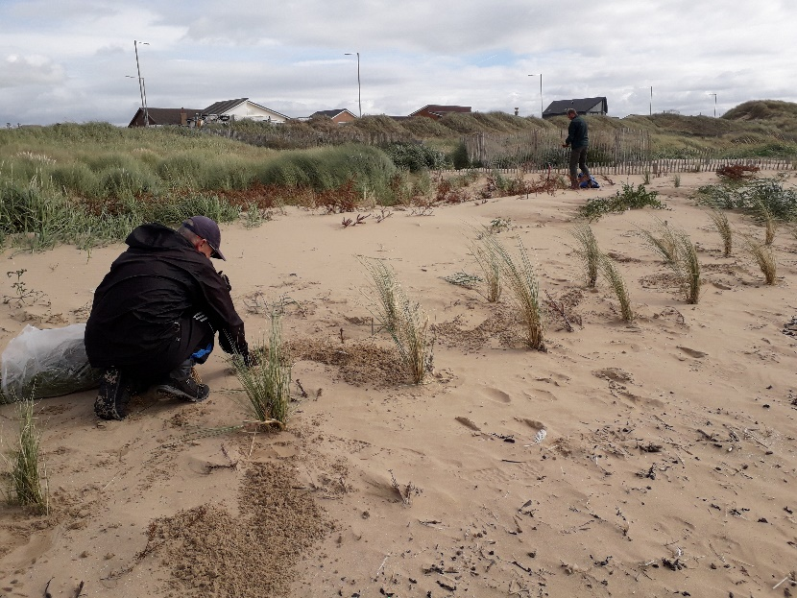

Wildlife Survey Volunteer
We are looking for people to join our team of wildlife recording volunteers on Fylde Sand Dunes Local Nature Reserve/ Site of Special Scientific Interest as well as on the Fylde Coast Special Protection Area. It is important for us to monitor what fantastic wildlife we have to make sure we are managing and maintaining our sites in the best possible way. All levels of experience and expertise are welcome. If you are new to wildlife recording then please don’t worry this is a great opportunity for those with little or no experience as training is provided.

What will you be doing?
- Plant surveys
- Invertebrate surveys
Bird surveys
Other protected animal species

What skills or knowledge do you need?
- Good species ID would be advantageous but overall willingness to learn and develop
- Experience with survey recording advantageous, but not essential
- Willingness to work outdoors in all weathers, often for considerable periods of time
- Comfortable with lone working
- Willingness to work anti-social hours if required
- Driving license advantageous but not compulsory
- Commitment and reliability.

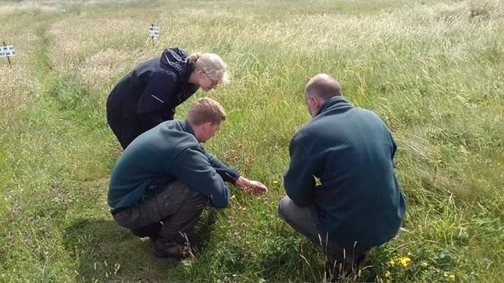

Volunteer Registration Form

About You
Name (inc. title)
Address
Postcode
Telephone No
Email Address
I am a UK/EU/EEA resident* |  | Yes/No | I am over 18? | Yes/No
*Please note Refugee Asylum Seekers cannot volunteer in the public sector and there are strong restrictions on people from outside the EU/EEA volunteering. For example, you cannot volunteer if you are in the UK on a visitor visa.
Your Interests
I am interested in volunteering for the following role (tick all that apply):
Volunteer Ranger Dunes Conservation Volunteer Wildlife Survey volunteer

Availability

My availability for volunteering is
Time/Day | Monday | Tuesday | Wednesday | Thursday |  | Friday | Saturday | Sunday
Morning
Afternoon
Evening
I am available at these times every: |  | Week/Fortnight/Month |  |  | (delete as appropriate)

Emergency Contact
Please provide the details of someone we can call in the unlikely event that you are taken ill or have an accident whilst volunteering with us.
Name (inc. title)
Address
Postcode
Telephone No
Mobile No
Email Address
Relationship to you

Health
Do you have a medical condition or allergy which you feel Fylde Borough Council should be made aware of or that could affect your ability to carry out the volunteer role? If yes, please give details in the space provided at the end of the form. | Yes/No
If yes, please give details below;

Is your immunisation against tetanus up to date? If no or you are unsure, you are strongly advised to seek medical advice and ensure that you are adequately protected. | Yes/No/Unsure

Media

Please indicate below where you heard about the role? (Internet, publication, family/friend, social media, etc.)

Why do you want to volunteer with Fylde council? What do you want to get out of your volunteering? (tick all that apply)

Career progression | Learn new skills | Health & wellbeing | Meeting people | Being outdoors | Contribution to community
Other

Declaration
To the best of my knowledge, the information I have provided on this form is true and accurate.
Signature
Name
Date

Data Protection
Your contact details are kept securely and are only used to contact you about matters relating to volunteering with Fylde Council. We will not release any personal information to a third party under any circumstances unless expressly authorised to do so by you, or if we are obliged to do so by law. We comply with the Data Protection Act 1998 and take all reasonable care to prevent any unauthorised access to your personal data
Returning Your Form
Thank you for your interest in volunteering with us. Please return this form to: Parks and Coastal Services, Snowden Road depot, Snowden Road, St. Annes, Lancashire, FY8 3DP. Email: rangers@fylde.gov.uk

Privacy Statement
Fylde Council is committed to protecting your privacy. It is very important to us and we respect anyone's concerns about maintaining it. This statement tells you how and why we use your information.

How we use your data
We do not sell your details to third parties. We will only use your data to keep you up to date with information about our group meetings, special events and information specific and relevant to our group.
You may change the way in which you receive information from us at any time:
Email: rangers@fylde.go.uk
Telephone: 01253 658469
Post: Snowdon Road, St Anne’s, FY8 3DP

Access to Your Own Information
You can contact us anytime by letter or telephone to change or update your details, or obtain a copy of your record. If you have any problems or queries about your data, please contact us on the details above or our data protection officer ian.curtis@fylde.go.uk

What is the lawful basis for processing my information?
Your consent is the lawful basis for processing your information.
Security
We ensure we take all the necessary steps to collect and store your data securely all data will be encrypted and therefore need a password to access it. All Fylde Council PCs and laptops are password protected and only persons authorised will be allowed to access data from within them. Laptops and PCs are stored securely overnight in alarmed and locked buildings.
Who is the data controller and how can you get in touch?
Fylde Council is the data controller. You can contact us by email at listening@fylde.gov.uk, by phone on 01257 658658, or at the Town Hall, St Annes Road West, Lytham St Annes FY8 1LW. Our Data Protection Officer can be contacted at the same address, or at dpo@fylde.gov.uk, or on 01253 658506.

What rights do you have about your data?
You have the right to request access to information about you that we hold. To make a request for your personal information, contact our Data Protection Officer, whose details are above.
You also have the right to:
- tell us to stop processing your data
- object to processing of personal data that is likely to cause, or is causing, damage or distress
- prevent processing for the purpose of direct marketing
- object to decisions being taken by automated means
- in certain circumstances, have inaccurate personal data rectified, blocked, erased or destroyed; and
- claim compensation for damages caused by a breach of the Data Protection regulations

If you have a concern about the way we are collecting or using your personal data, we request that you raise your concern with us in the first instance. Alternatively, you can contact the Information Commissioner’s Office at https://ico.org.uk/concerns/

