BUSINESS AND PLANNING ACT 2020

APPLICATION FOR THE GRANT OF A PAVEMENT LICENCE

APPLICANT DETAILS
Title: MR | First name(s): MARTIN | Surname: GILLETT
Postal Address:

Post Town: |  | Post Code:
Phone (Home): |  | Phone (Mobile):
e-mail address:
Date of Birth: |  | NI number:

BUSINESS PREMISES DETAILS
Trading Name: THE PIER INN
Postal Address:
8 ST ANNES ROAD WEST
ST ANNES
FY8 1RF

Which of the following is the above premises used for? (please tick one of the following options)
Use as a public house, wine bar or other drinking establishment | ✔
Other use for the sale of food or drink for consumption on or off the premises
Both of the above uses

AREA OF HIGHWAY PROPOSED TO BE USED
Please provide a description of the area of the highway to which this application relates:
(Please note you are required to submit a scale plan of this area with your application)
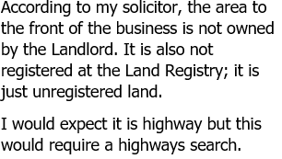
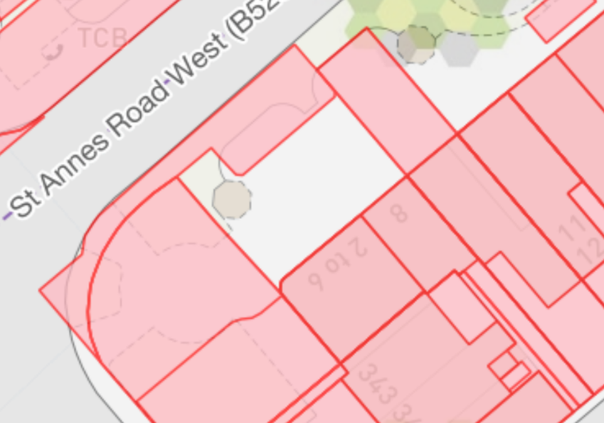
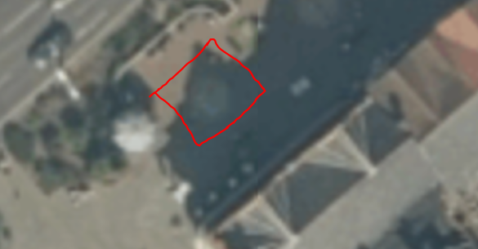

RELEVANT PURPOSE THE APPLICATION RELATES TO:
Which of the following relevant purposes do you wish to put furniture on the highway for?
(please tick one of the following options)
To sell or serve food or drink supplied from, or in connection with relevant use of, the premises
For the purpose of consuming food or drink supplied from, or in connection with relevant use of, the premises
Both of the above purposes | ✔

DAYS AND TIMES
During what times do you propose to place furniture on the highway on each of the following days:
Please use the 24hr clock.
Mondays | 09:00 to 21:00 | Fridays | 09:00 to 21:00
Tuesdays | 09:00 to 21:00 | Saturdays | 09:00 to 21:00
Wednesdays | 09:00 to 21:00 | Sundays | 10:00 to 21:00
Thursdays | 09:00 to 21:00

FURNITURE TO BE PLACED ON THE HIGHWAY
Please provide a description of the furniture you propose to place on the highway
(Please note you are required to provide photographs or brochures of the proposed furniture with your application)
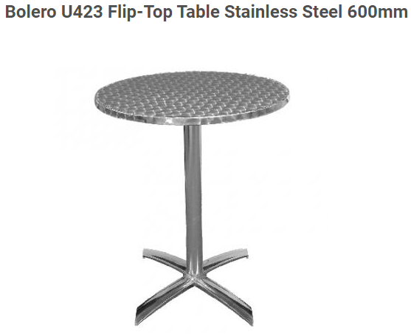
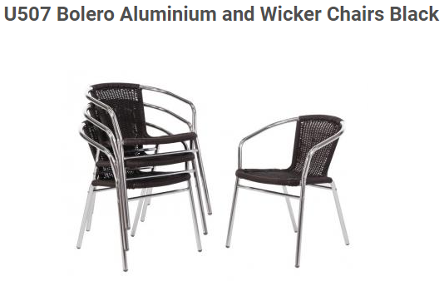
Up to 10 tables with up to 40 chairs from https://www.caterkwik.co.uk/

DATE OF APPLICATION
Please state the date that this application for a Pavement Licence is being submitted | Friday 22nd April, 2022
If you have previously used the highway to which this application relates, with or without a licence, state the date this use started.

DECLARATIONS BY APPLICANT
I understand that I am required to give notice of my application in accordance with the requirements of the Business and Planning Act 2020 and that failing to do so will lead to the revocation of any licence granted.
I understand I must hold and maintain public liability insurance up to a value of £5million.
I understand my application will not be considered to be complete until all the required documents and information have been provided and the application fee of £100 has been paid.
I understand that the application fee paid is non-refundable if my application is refused or if any licence granted is subsequently surrendered or revoked.
I understand that the Authority is under a duty to protect the public funds it administers, and to this end may use the information I have provided on this form for the prevention and detection of fraud. I understand that it may also share this information with other bodies responsible for auditing or administering public funds for these purposes.
I declare that the information given above is true to the best of my knowledge and that I have not wilfully omitted any necessary material. I understand that if there are any wilful omissions, or incorrect statements made, my application may be refused without further consideration or, if a licence has been issued, it may be liable to revocation.
I understand that the Authority is collecting my data for the purposes described on this form and will not be used for any other purpose, or passed on to any other body, except as required by law, without my consent.
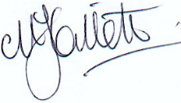
Signature:

Print Name:
MARTIN J GILLETT
Date: Monday 28 March, 2022

GUIDANCE Notes

Submission of the Application

An application for a Pavement Licence must be made to the Council, and the following will be required to be submitted with the application:
- a completed Application Form
- the required fee of £100,
- a plan showing the location of the premises shown by a red line, so the application site can be clearly identified
- a plan clearly showing the proposed area covered by the licence in relation to the highway, if not to scale, with measurements clearly shown. The plan must show the positions and number of the proposed tables and chairs, together with any other items that they wish to place on the highway. The plan shall include clear measurements of, for example, pathway width/length, building width and any other fixed item in the proposed area.
- the proposed days of the week on which, and the times of day between which, it is proposed to put furniture on the highway,
- evidence of the right to occupy the premises (e.g. the lease);
- photos or brochures showing the proposed type of furniture and information on potential siting of it within the area applied;
- (if applicable) reference of existing pavement licence currently under consideration by the local authority;
- evidence that the applicant has met the requirement to give notice of the application (for example photographs of the notice outside the premises and of the notice itself);
- a copy of a current certificate of insurance that covers the activity for third party and public liability risks, to a minimum value of £5 million, and
- any other evidence needed to demonstrate how the Council’s local conditions, and any national conditions will be satisfied.
These documents and this application form must be sent to licensing@fylde.gov.uk

