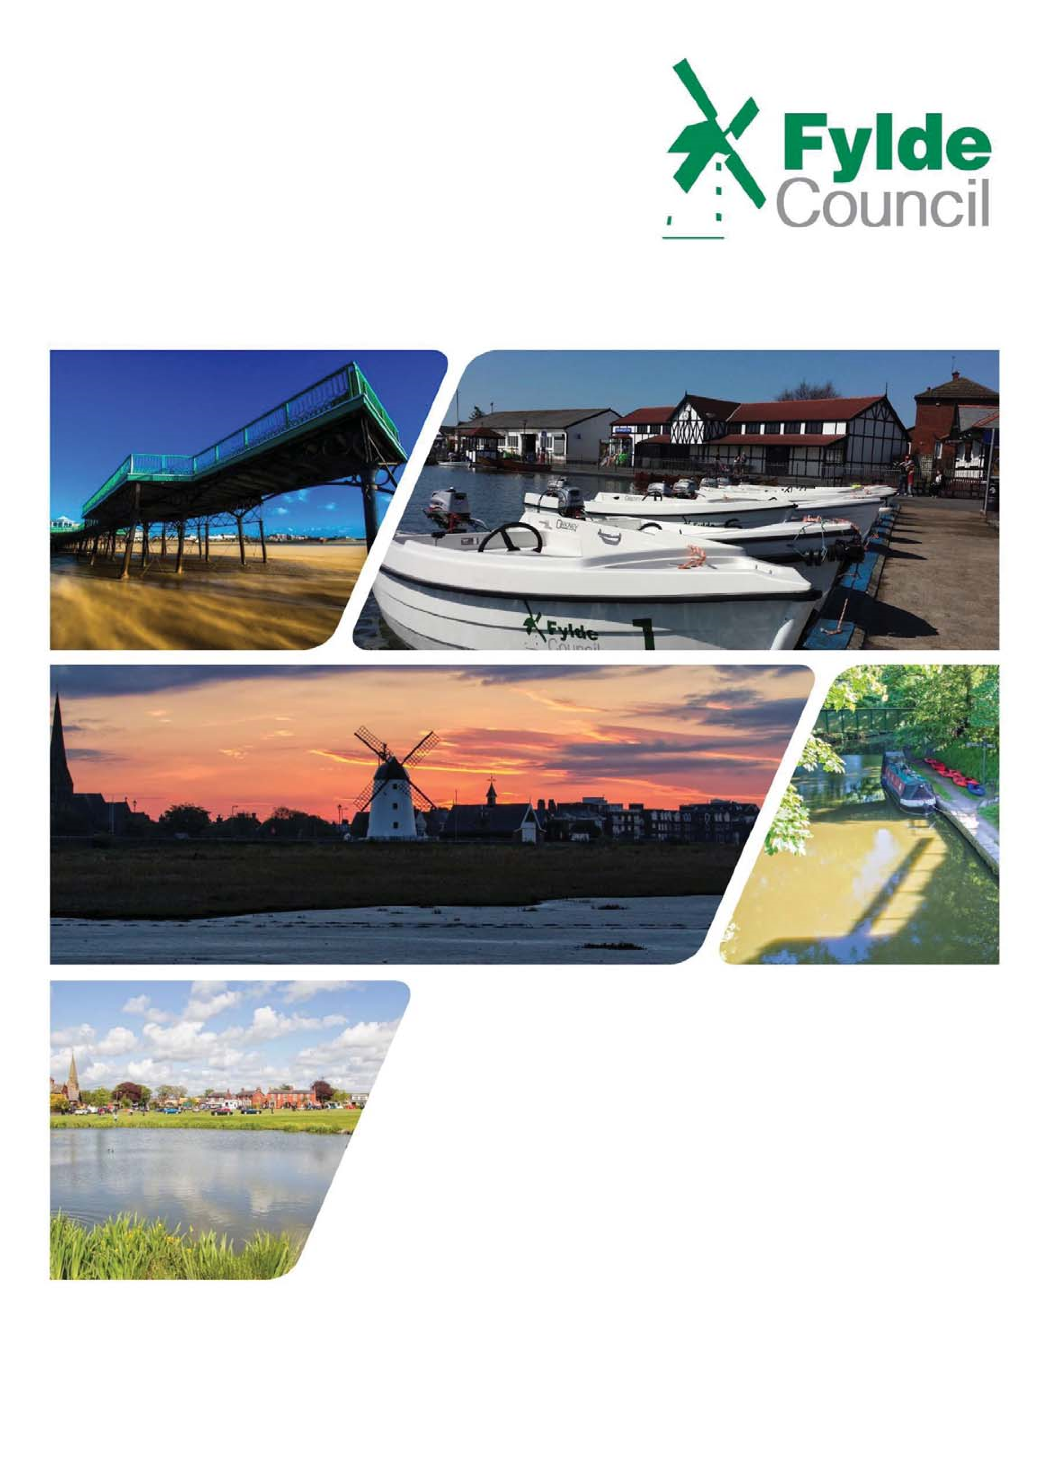

Gender Pay Gap

Information 2020

1.0 Introduction

Gender Pay Gap reporting legislation requires large employers such as ourselves to publish their overall mean and median gender pay gaps from 2018. Under the new laws, employers will have to calculate their gender pay gap from April 2017.

This is therefore the fourth year gender pay gap data has been reported.
2.0 Context

Fylde Council is a District Council which provides a variety of diverse services to over 77,000 Fylde residents.

All Fylde Council employees are remunerated according to set pay scales; posts are regularly reviewed and agreed by employee representatives through a formal job evaluation system.

Our workforce is currently 250 employees of whom two thirds are male (62.4 %).

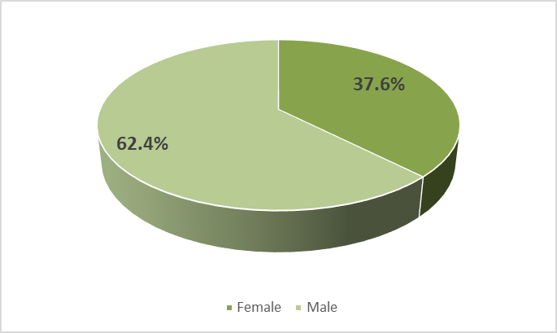

Fylde Council is committed to eliminating discrimination and encouraging equality and diversity in our workforce.
3.0 Data
1 | Mean Pay Gap | 0.93
2 | Median Pay Gap | -14.84
3 | Mean bonus gender pay gap* | *Fylde Council does not operate any bonus scheme and therefore has no bonus gender pay gap.
4 | Median bonus gender pay gap*
5 | Proportion of males /females receiving a bonus payment
6 | Proportion of males and females in each quartile pay band

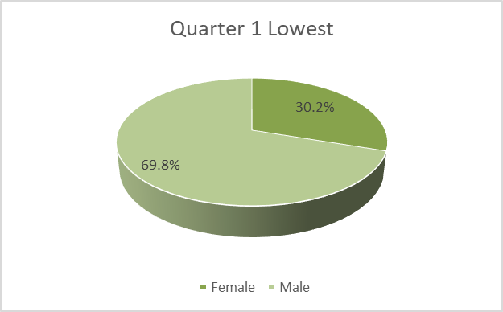 | 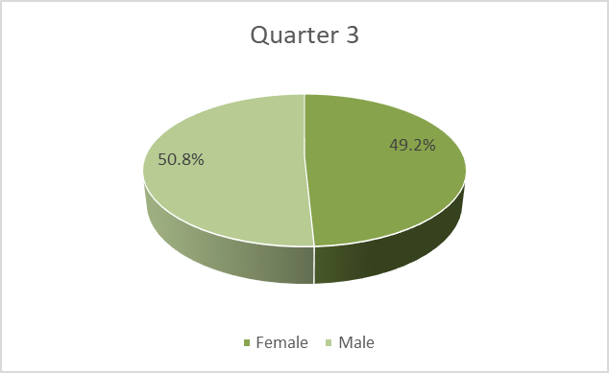
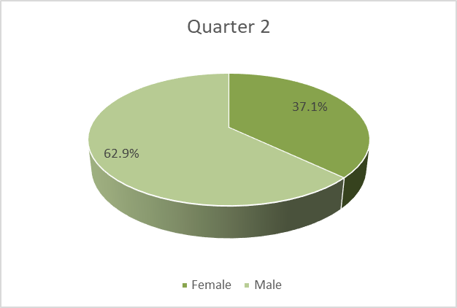 | 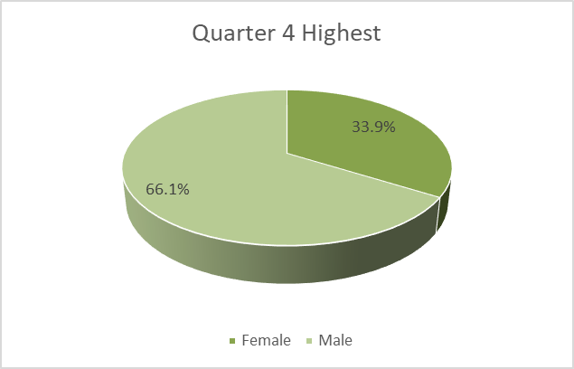

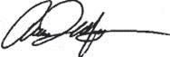
We confirm that the data provided is accurate.

Signature:
Date:

Allan Oldfield, Chief Executive

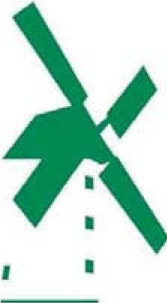

Fylde

Council

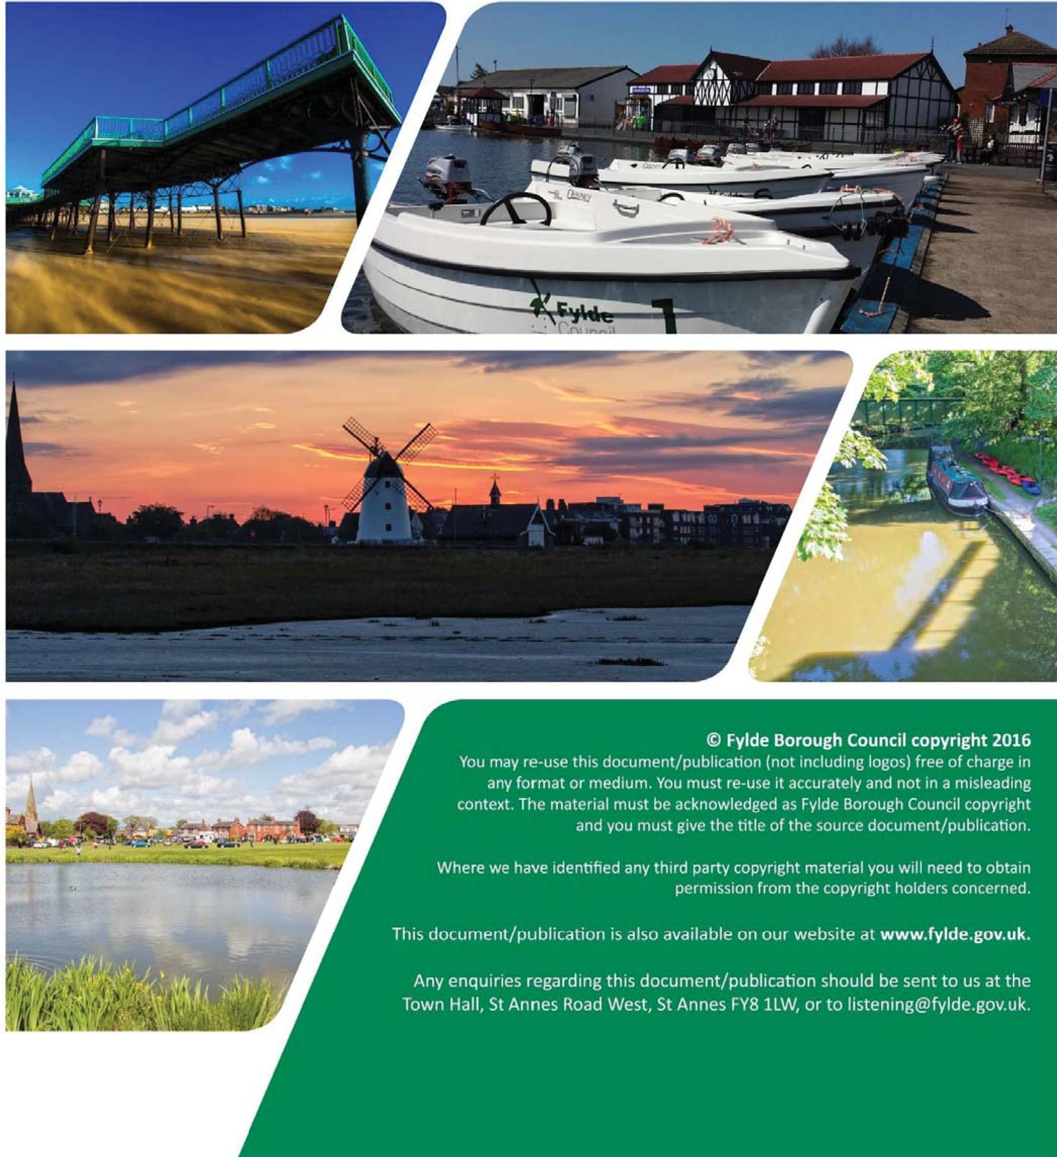

Number of those employees in scope of the Gender pay gap.

