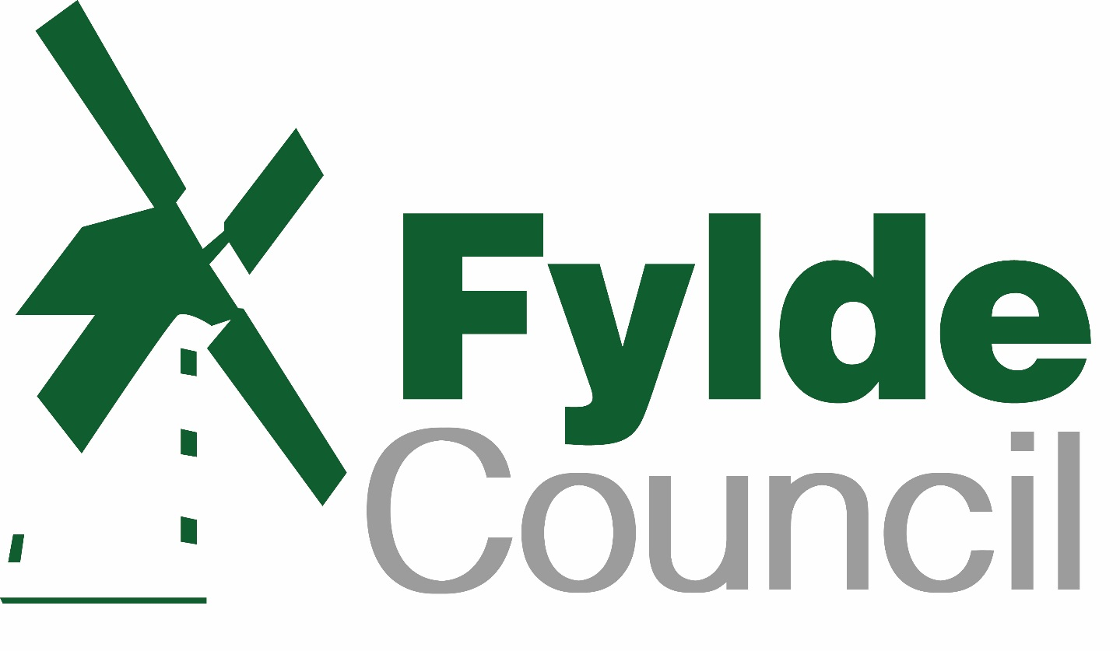

Risk Management Strategy 2020
FOREWORD

Welcome to the Council’s Strategic & Operational Risk Management Strategy, refreshed in January 2020. The aim of the Strategy is to improve strategic and operational risk management throughout the Council. Effective risk management allows the Council to:

- have increased confidence in achieving its corporate objectives

- mitigate threats to acceptable levels

- take informed decisions about exploiting opportunities

- ensure that it gets the right balance between rewards and risks

- improve its partnership working arrangements and corporate governance

Effective risk management will help to ensure the Council maximises its opportunities and minimises the impact of the risks it faces, thereby improving its ability to deliver its core objectives and improve outcomes for its residents.

This strategy explains Fylde Council’s approach to strategic and operational risk management, and the framework that it will operate to ensure that it arranges its risks effectively.

Allan Oldfield
Chief Executive
Fylde Council

Information Box
Title | Risk Management Strategy version 5.0 revised August 2020
Description | Fylde Borough Council’s Risk Management Strategy
Primary audience | Members, Chief Executive, Corporate Management Team, Heads of Service and all Fylde Borough Council staff
Contact | Head of Internal Audit Tel. No.: 01253 658413
Last revised | May 2017

1. Risk Management Objectives

We are exposed to risk both in terms of threats to service provision and from missed opportunities. It is essential that we can demonstrate to our residents that we are fully considering the implications of risk as we plan and deliver services to the community.

Like all organisations, the Council exists to achieve its objectives which are set out in our Corporate Plan. Risk management can help us achieve these goals by fully considering the opportunities and barriers that we may encounter. Our aim is to use strategic risk management as a tool for continuous improvement and to make effective use of the Council’s resources.

In addition the Council must also ensure operation and delivery of services, the health and safety of its service users, employees and the public at large. This Risk Management Framework supports continuing change including partnership working and alternative methods of service delivery and provides a structured and focused approach to managing them.

This strategy outlines how Fylde Council is taking on its responsibility to manage risks and opportunities using a structured and focused approach.

2. What is Risk Management?

Risk Management can be defined as:

Risk management is the logical and systematic method of identifying, analysing, evaluating, treating, monitoring and communicating risks associated with any activity, function or process in a way that enables organisations to minimise losses, maximise opportunities and achieve their objectives.

Risk management is a strategic tool and is an essential part of effective and efficient management and planning. Risk management is also an essential part of the CIPFA/SOLACE framework on Corporate Governance. The CIPFA/SOLACE framework requires Fylde Council to make a public assurance statement annually, on amongst other areas, the Council’s risk management strategy, process and framework. The Framework requires the Council to establish and maintain a systematic strategy, framework and processes for managing risk. As required by the Accounts and Audit Regulations 2015 the assurance statement is disclosed in the Annual Statement of Accounts and is signed by the Leader of the Council and the Chief Executive.

3. Risk Management approach

The Council will seek to embed risk management into its culture, processes and structure to ensure that opportunities are maximised. The council will seek to encourage managers to identify, understand and manage risks, and learn how to accept the right risks. Adoption of this strategy must result in a real difference in the Council’s behaviour.

The Council is prepared to take judicious risks to achieve it’s corporate objectives and enhance the value of the services it provides to the community. Its aims are to:

- Ensure risk management is integrated into the culture of the council
- Ensure appropriate risk taking is encouraged, particularly to respond to opportunities arising.
- Anticipate and respond to changing social, environmental and legislative needs, pressures or constraints as well as changes in the internal environment.
- Manage risk in accordance with best practice including integration with performance and financial management including partnership arrangements.
- Improve performance and efficiency and in particular minimise injury, damage and losses and make effective use of resources.
- Protect the council’s assets, reputation and operational capacity.

These aims will be achieved by:

- Maintaining clear roles, responsibilities and reporting lines for risk management
- Raising awareness of the need for risk management by all those connected with the Council’s delivery of services.
- Gaining commitment from all members and employees, to ensure risk management is managed within a consistent framework.
- Ensuring risk management is explicitly considered in all decision making by, incorporating links to all key decision points e.g. committee reports, project management and partnership agreements.
- Considering risk in all the Council’s key planning processes.
- Providing opportunities for shared learning on risk management across the Council and with our business partners.
- Reinforcing the importance of effective risk management as part of the everyday work of members and employees.
- Providing adequate assurance for the management of risk to support the Annual Governance Statement.

5. Risk Management Processes

Implementing the strategy involves identifying, analysing, managing and monitoring risks.

Risk Identification
The GRACE (Governance, Risk Assessment and Control Evaluation) system has been adopted for use within the Council to enable the completion of risk registers at all levels including the Strategic risk register, service risk registers, projects, key procurements, partnerships and processes.

Risks and opportunities can be identified at any time and should be included within GRACE. There are numerous ways in which risks and opportunities can be identified, including networking, articles / newsletters, training courses as well as discussions at team meetings and
1-2-1s. In addition, GRACE contains a large database of model risks and controls in the Profile Library which users can scroll through to identify any which may be relevant to their areas of activity.

Risk Recording
The Council maintains registers for different types of risks:

Strategic risk register – This contains the high level risks of the council. It is owned and maintained by the Council’s Management Team and Strategic Risk Management Group and kept under continuous review. It is presented to the Audit and Standards Committee every six months.

Operational risk registers – These include service, project, partnerships and process risks. These are assigned to specific Directors and Senior Managers who have overall responsibility for their maintenance and continuous review. They can allocate individual risks to risk owners who must decide upon and monitor appropriate actions.

The specific information to be recorded in GRACE is as follows:

Risk description – this requires an understanding of the legal, social, political and cultural environment in which the council operates as well as a sound understanding of the Council’s corporate and operational objectives i.e those factors which are critical to the success of the Council.

Risk Owner – a nominated person who is responsible for evaluating and responding to any individual risks allocated to them.

Assessment of Risk – having identified areas of potential risk, they need to be systematically and accurately assessed. The process requires managers to make an assessment of the likelihood and potential impact of a risk event occurring and scored according to the matrix below:

Severity | 5 | Catastrophic
 | 4 | Major
 | 3 | Moderate
 | 2 | Minor
 | 1 | Insignificant
 |  |  | 1 | 2 | 3 | 4 | 5
 |  |  | Rare | Unlikely | Possible | Likely | Almost Certain
 |  | Likelihood

Likelihood Definitions

1 – Rare | Highly unlikely, but it may occur in exceptional circumstances. It could happen but probably never will
2 - Unlikely | Not expected, but there’s a slight possibility it may occur at some time
3 - Possible | The event might occur at some time as there is a history of casual occurrence at FBC and / or similar organisations
4 – Likely | There is a strong possibility the event will occur as there is a history of frequent occurrence at FBC and / or similar organisations
5 – Almost certain | Very Likely. The event is expected to occur in most circumstances as there is a history of regular occurrence at FBC and / or similar organisations.

Severity Definitions

1 - Insignificant | Minimal Financial Loss, no or only minor personal injury. Systems unavailable for less than an hour. No reputational impact.
2 - Minor | £1000 - £10,000 financial loss. Minor injury requiring medical treatment. Systems unavailable for a few hours. Adverse media coverage
3 - Moderate | £10,000 - £50,000 financial loss. Possible hospitalisation, systems unavailable for less than 1 day, adverse national media coverage
4 - Major | £50,000 - £750,000 financial loss. Single death or long term illness or multiple injuries, systems unavailable for a day, adverse and extended media coverage
5 - Catastrophic | Above £750,000 financial loss. Fatalities or permanently ill/disabled, systems unavailable for more than a day, government / HSE enquiry.

Existing Control Measures – any controls or measures that reduce the likelihood or impact of a risk.

Residual Risk Score – this risk score which takes account of any existing control measures in place (see above matrix).

Risk Categories – risks should be assigned to one of the categories listed below:

- Strategic – risks impacting upon the achievement of the corporate objectives and priorities;
- Financial – risks associated with financial planning and control;
- Human Resources – risks associated with recruiting, retaining and motivating staff & developing skills;
- Environmental – risks related to pollution, noise or energy efficiency;
- Information – risks related to information held;
- Legal / regulatory – risk relating to legal / regulatory requirements;
- Operational – risks relating to operational activity;
- Partnership / Contractual – risk relating to the failure of partners / contractors or the contract itself;
- Physical – risk related to fire, security, accident prevention & health and wellbeing;
- Reputational – risk relating to the reputational risk to the council;
- Technological – risks associated with technology.

Target Risk Score – in broad terms there are four main options for responding to risks which remain within the organisation.

Terminate - this involves the Council in terminating the cause of the risk or, opting not to take a current or proposed activity because it believes it is too risky.

Tolerate - this is where the cost of action outweighs the benefit that results from the proposed action. Alternatively no further action can be taken and the risk is accepted with any potential financial loss being highlighted.

Transfer - this involves transferring liability for the consequences of an event to another body. This can occur in two forms. Firstly legal liability may be transferred to an alternative provider under contractual arrangements for service delivery. Secondly, transferring some or all of the financial risk to external insurance companies may reduce the costs associated with a damaging event.

Treat - this is dependent on implementing projects or procedures that will minimise the likelihood of an event occurring or limit the severity of the consequences should it occur.

The target risk score therefore may be the same or lower than the residual risk score and reflects the level of risk the Risk Owner is willing to accept (see above matrix).

Risk Actions – where further treatment of the risk is deemed necessary then the Risk Owner will determine the course of action to be taken. The action to manage risk needs to be appropriate, achievable and affordable. The impact expected if no action is taken should be considered against the cost of action and the reduction of the impact. For opportunities, the benefit gained in relation to the cost of action should be considered.

Risk Monitoring

Individual risks are reviewed in accordance with GRACE parameters depending upon the level of risk:

Red / Pink risks – 3 months
Amber / Yellow risks – 6 months
Green risks – 12 months.

The overall risk management system is reviewed by Internal Audit as part of their annual audit work

In accordance with the Public Sector Internal Auditing Standards the Chief Internal Audit Executive’s Annual Report is required to provide an opinion based on an objective assessment of the framework of governance, risk management and control.

Risk management assurance will also be published in the Council’s Annual Governance Statement.

Risk Reporting

The Strategic Risk Register is continuously monitored by the Council’s Management Team and Strategic Risk Management Group and reported to the Audit and Standards Committee every six months.

Service Risk Registers and those in relation to key projects, procurements, partnerships and processes are monitored by Directors and Heads of Service.

GRACE has also enabled a modern risk-based approach to internal auditing by engaging service departments in the self-assessment of their own system risks via the completion of on-line risk registers prior to the commencement of audits. System/process risks are reported as part and parcel of ongoing Internal Audit work.

Finally, all Committee reports include the consideration and control of the risks associated with the actions proposed.

6. Roles and Responsibilities

The following describes the roles and responsibilities that members and officers will play in introducing, and embedding the risk management process: -

All members

- Support and promote an effective risk management culture.
- Constructively review and scrutinise the risks involved in delivering the council’s core purpose, priorities and outcomes.

Chairs of Committees

- Risk manage the council in delivering its core purpose, priorities and outcome.
- Consider and challenge the risks involved in making any ‘key decisions’.

The Audit and Standards Committee

- In accordance with their Terms of Reference, monitor the effective development and operation of risk management in the council.
- To monitor progress in addressing risk relating issues reported to the committee.

The Chief Executive, Corporate Management Team & Strategic Risk Management Group

- Champion an effective council-wide risk management culture, with the Director of Resources as the designated CMT lead on Risk
- Identify and manage the business risks and opportunities facing the Council
- Co-ordinate risk management across the Council
- Ensure members receive relevant risk information

Directors & Heads of Service

- Responsible for the effective leadership and management of risk in their service areas to meet service objectives in line with the Council’s Risk Management Strategy
- With the appropriate risk owner, maintain the relevant risk registers ensuring all key risks are identified, managed and reviewed in line with the corporate risk management approach
- Review and evaluate operational, project, partnership risks within their Directorate at team meetings, 1-2-1s etc.
- Attending (& Chairing) the Strategic Risk Management Group
- Encourage staff to be open and honest in identifying risks and opportunities
- Ensure that appropriate resources and importance are allocated to the process
- Provide assurance that the risks for which they are the risk owner are being effectively managed. This will be completed as part of the Annual Governance review process.

The Section 151 Officer

- Through the Internal Audit Service, provide assurance to the Council on the whole system of internal control, including risk management.

Internal Audit

- As part of its role in providing assurance to the Section 151 officer, will review the implementation and effectiveness of the system of risk management. An annual report will provide independent opinion on the adequacies of risk control and the Council’s corporate governance arrangements and also risk management is included within the review of the Annual Governance Statement.
- Act as a centre of expertise, providing support and guidance as required
- Collate risk information and prepare reports as necessary to both the Management Team, Strategic Risk Management Group and the Audit & Standards Committee
- Ensure the Internal Audit work plan is focused on the key risks facing the council
- During all relevant audits, challenge the content of risk registers
- Periodically arrange for the independent review of the council’s risk management process and provide an independent objective opinion on its operation and effectiveness.

Project / Procurement Managers

- Ensure that the risks associated with their projects / procurements are identified, recorded on GRACE and regularly reviewed as part of the project management process and provide assurance about the management of those risks.

Partnerships

- client officers to ensure that risks are identified, owned, recorded on GRACE reviewed and shared with all relevant partners and ultimately to provide assurance that those risks are being managed.

Employees

- responsibility for managing risk is not restricted to any one person or group of specialists. All employees have a responsibility to manage risk effectively in their job and report opportunities, threats and risks to their Directors and undertake their duties within risk management guidelines. Those officers involved in decision-making should also explicitly consider the implications of risk management and document their findings appropriately.

Appendix A

Strategic Risk Management Group – Terms of Reference

Meetings
The Strategic Risk Management Group (SRMG) will meet on a regular basis (minimum of 4 meetings per year); however the Chairman may call extra meetings as necessary.

Chairmanship
The Chairmen of the Group will normally be appointed by the CMT and will usually be a Director.

Secretary
The Secretary of the Group will normally be appointed by the CMT and will be someone who works on operational risk.

Membership of the Group
Every directorate will be represented at the Group. Each directorate will nominate a senior member of the directorate to represent the directorate at SRMG. Directorate membership should, where possible, be rotated over a cycle of a number of meetings so that risk management is promoted to as many senior officers as possible. Additional staff members may attend the meeting where it is considered beneficial to have their input on matters being discussed.

Purpose, Focus and Scope of the Risk Management Group

- The purpose of the SRMG is to promote good practice on risk management across the Authority and act as a “Champion” on risk management issues.
- SRMG should promote the “positive” effects that good risk management can have when embedded into all Council policies and procedures.
- Risk management should be seen as a tool to “make things happen” in a safe and beneficial way, not a process used to “stop things from progressing”.
- SRMG should investigate issues referred to it by the Corporate Management Team and report back in a timely manner.
- SRMG should also advise Corporate Management Team on risk management issues referred to it by directorates.
- The SRMG manages ‘corporate risks’ which affect the Council’s ability to fulfil its Corporate Objectives and is concerned with major Business risk.
- The RMG will also monitor the Council’s Emergency Planning, Business Continuity and Disaster Recovery Plans, as well as Information Security/Risk and Data Protection

Minutes and Reports
Minutes of meetings should be kept and the Chairman of each Group should present these to the Corporate Management Team at the next available meeting. All reports issued by the groups should also be reported to CMT. Once minutes and reports are approved by the CMT they should be posted onto the risk management page of the Intranet.

