
FYLDE HOMELESSNESS, HOUSING ADVICE AND TENANCY SUPPORT POLICY January 2020

FYLDE HOMELESSNESS, HOUSING ADVICE AND ROUGH SLEEPING POLICY
January 2020
Our vision and values
Our vision is to work to prevent and relieve homelessness in Fylde and provide homelessness services with our partners that are accessible, professional and make a difference.
We will work to ensure all our clients facing homelessness have:
- Access to expertise needed to enable clients to engage with a range services that will support them to resolve their housing situation and improve their health and wellbeing.
- The confidence to access and maintain a tenancy with the skills required to ensure their home is affordable, settled and if they are facing difficulties know who to approach for help.
To support this vision we have the following 6 values in the way we manage the housing service within Fylde Borough Council

We believe that everyone who is homeless should have a right to:

- A safe, secure home, and if needed, an appropriate level of support to create a good quality of life
- The full protection of the law, and not be subjected to violence, abuse, theft and discrimination
- Communication methods website, leaflets and personal housing plans that give clients an understanding of the service they will receive and actions they need to take as they move between support services into accommodation
- Be treated in a courteous and respectful manner
- All opportunities for contact are captured and maximised to ensure engagement
- People with experience of homelessness have a voice, their opinions matter and they are involved
in determining the solutions to their own issues.

FYLDE HOMELESSNESS AND ROUGH SLEEPING STRATEGY 2020-2025
The Fylde Homelessness and Rough Sleeping Strategy 2020-25 outlines our vision and values to relieve homelessness in Fylde and provide homelessness services with our partners that are accessible, professional and make a difference.

We will work to ensure all clients facing homelessness have access to a range of services that will support their housing situation and improve health and well-being.

A Tenancy Support service has been implemented in order to support vulnerable tenants whom approach our service with complex needs. The aim of this service is to minimise the risk of tenancy breakdown, for those who are at a higher risk of tenancy failure within both social and private sector accommodation.

TENANCY SUPPORT SERVICE

The Tenancy Support package is designed to assist vulnerable tenants with settling into accommodation. The initial tenancy support that we provide will last for a period of 12 weeks however, if we feel that additional support is required, we can look to review this dependent on the needs of the individual.
We can provide support in several different areas including; welfare benefits, referrals for debt advice, referrals to mental health services and substance misuse agencies, assistance with setting up bills once a tenancy is obtained and completing regular home visits to discuss how the tenancy is progressing and how they are managing to live independently.
By ensuring that all the correct services are in place to promote positive health and wellbeing and providing one to one support; we aim to prevent re-occurring failures of tenancies.
The intensity of the support provided is defined by reviewing the needs of the client and categorising them into one of three of the support services that we have available. These are;

- Housing Advice and Homelessness Service
- Tenancy Support
- Rapid Rehousing Tenancy Support

Within the initial assessment process of a client approaching our service their needs will be discussed, identified, and a synopsis of their housing history will be obtained. We ask the client to provide authorisation for Fylde Council to make the necessary enquiries with differing agencies to gather as much information as possible to ensure the provision of a holistic approach when offering support. Once the client’s needs are known, they are placed into one of the above services. Below we have compiled a flow chart of how this is allocated;

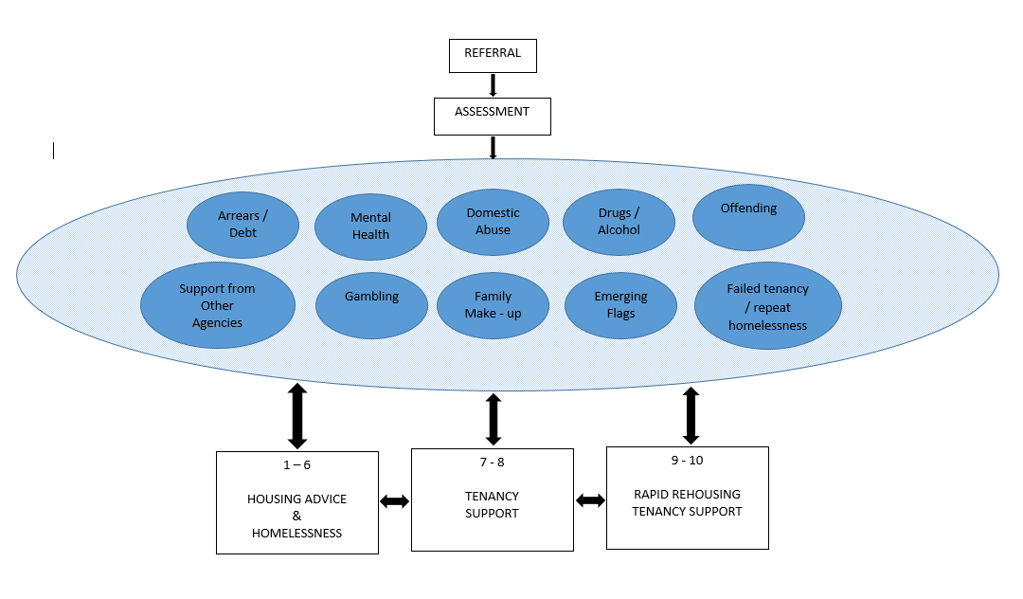

The Housing Advice and Homelessness service can provide tenancy support to those whom present to us, with 1-6 of the needs listed above.

For any clients whom approach us with 7-8 of the complex needs, they are provided with a 12-week tenancy support plan. The tenancy support worker will use a personalised approach to undertake assessments of all new clients by developing an individual programme of support, ‘Support Plan’, for each case with the objective of promoting and encouraging independence and ensuring tenancy sustainment. The tenancy support worker will also co-ordinate multi agency Support Plans that give solutions to: Access to accommodation, welfare benefits, pre-tenancy training, work readiness, engagement and relevant health services, volunteering, Job Club, CV writing and interviewing techniques, physical activity and life skills training.
The Rapid Rehousing tenancy support will provide an intensive support to those of whom approach us with 9-10 of the identified complex needs. The Rapid Rehousing Officer will provide support to set up the tenancy, arrange move in and provide flexible support to maintain the tenancy on an on-going basis. This will also include a personal budgeting allowance. The Rapid Rehousing officer will maintain links with services from partner agencies to ensure clients continue to receive support to address health and wellbeing and act as a single point of contact. All assessments, personalised housing plans, decisions and actions are implemented using the Homeless Reduction Act 2017.

HOMELESSNESS AND HOUSING ADVICE SERVICE
The Homelessness Reduction Act 2017 came into force on 3 April 2018. It is the biggest change to homelessness legislation in 40 years and brought in new duties to prevent and relieve homelessness.
The key measures in the Act are:
- an extension of the period ‘threatened with homelessness’ from 28 to 56 days.
- a new duty to prevent homelessness for all eligible applicants threatened with homelessness, regardless of priority need.
- a new duty to relieve homelessness for all eligible homeless applicants, regardless of priority need.
- A new ‘duty to refer’ - public services will need to notify a local authority if they come into contact with someone they think may be homeless or at risk of becoming homeless.

The following flowcharts details the process we will work towards with clients to support them with their housing situation.

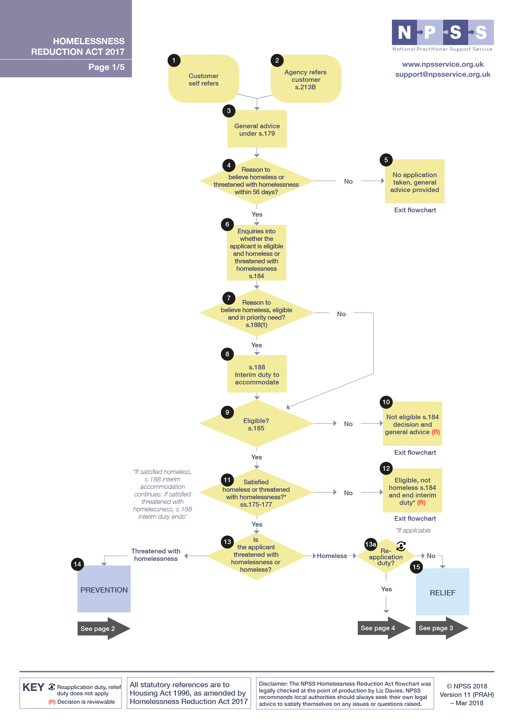

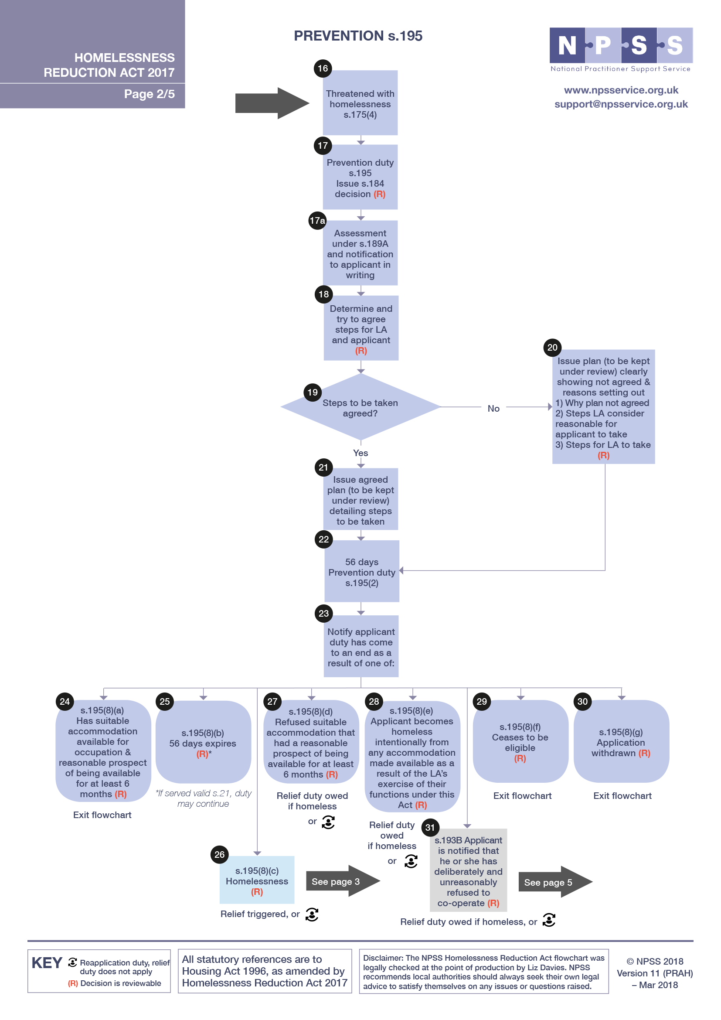

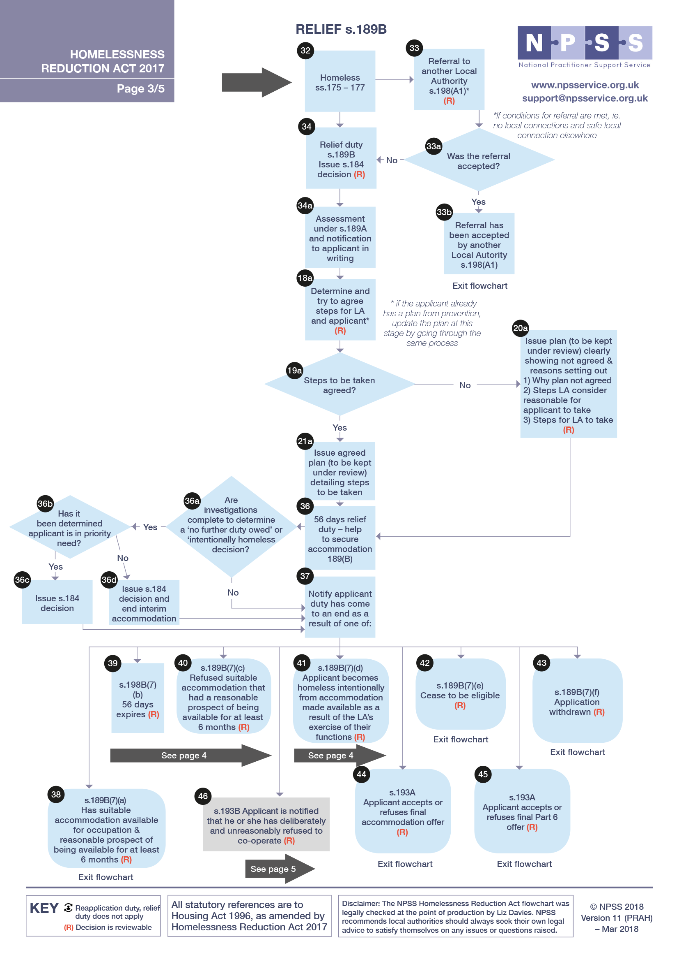

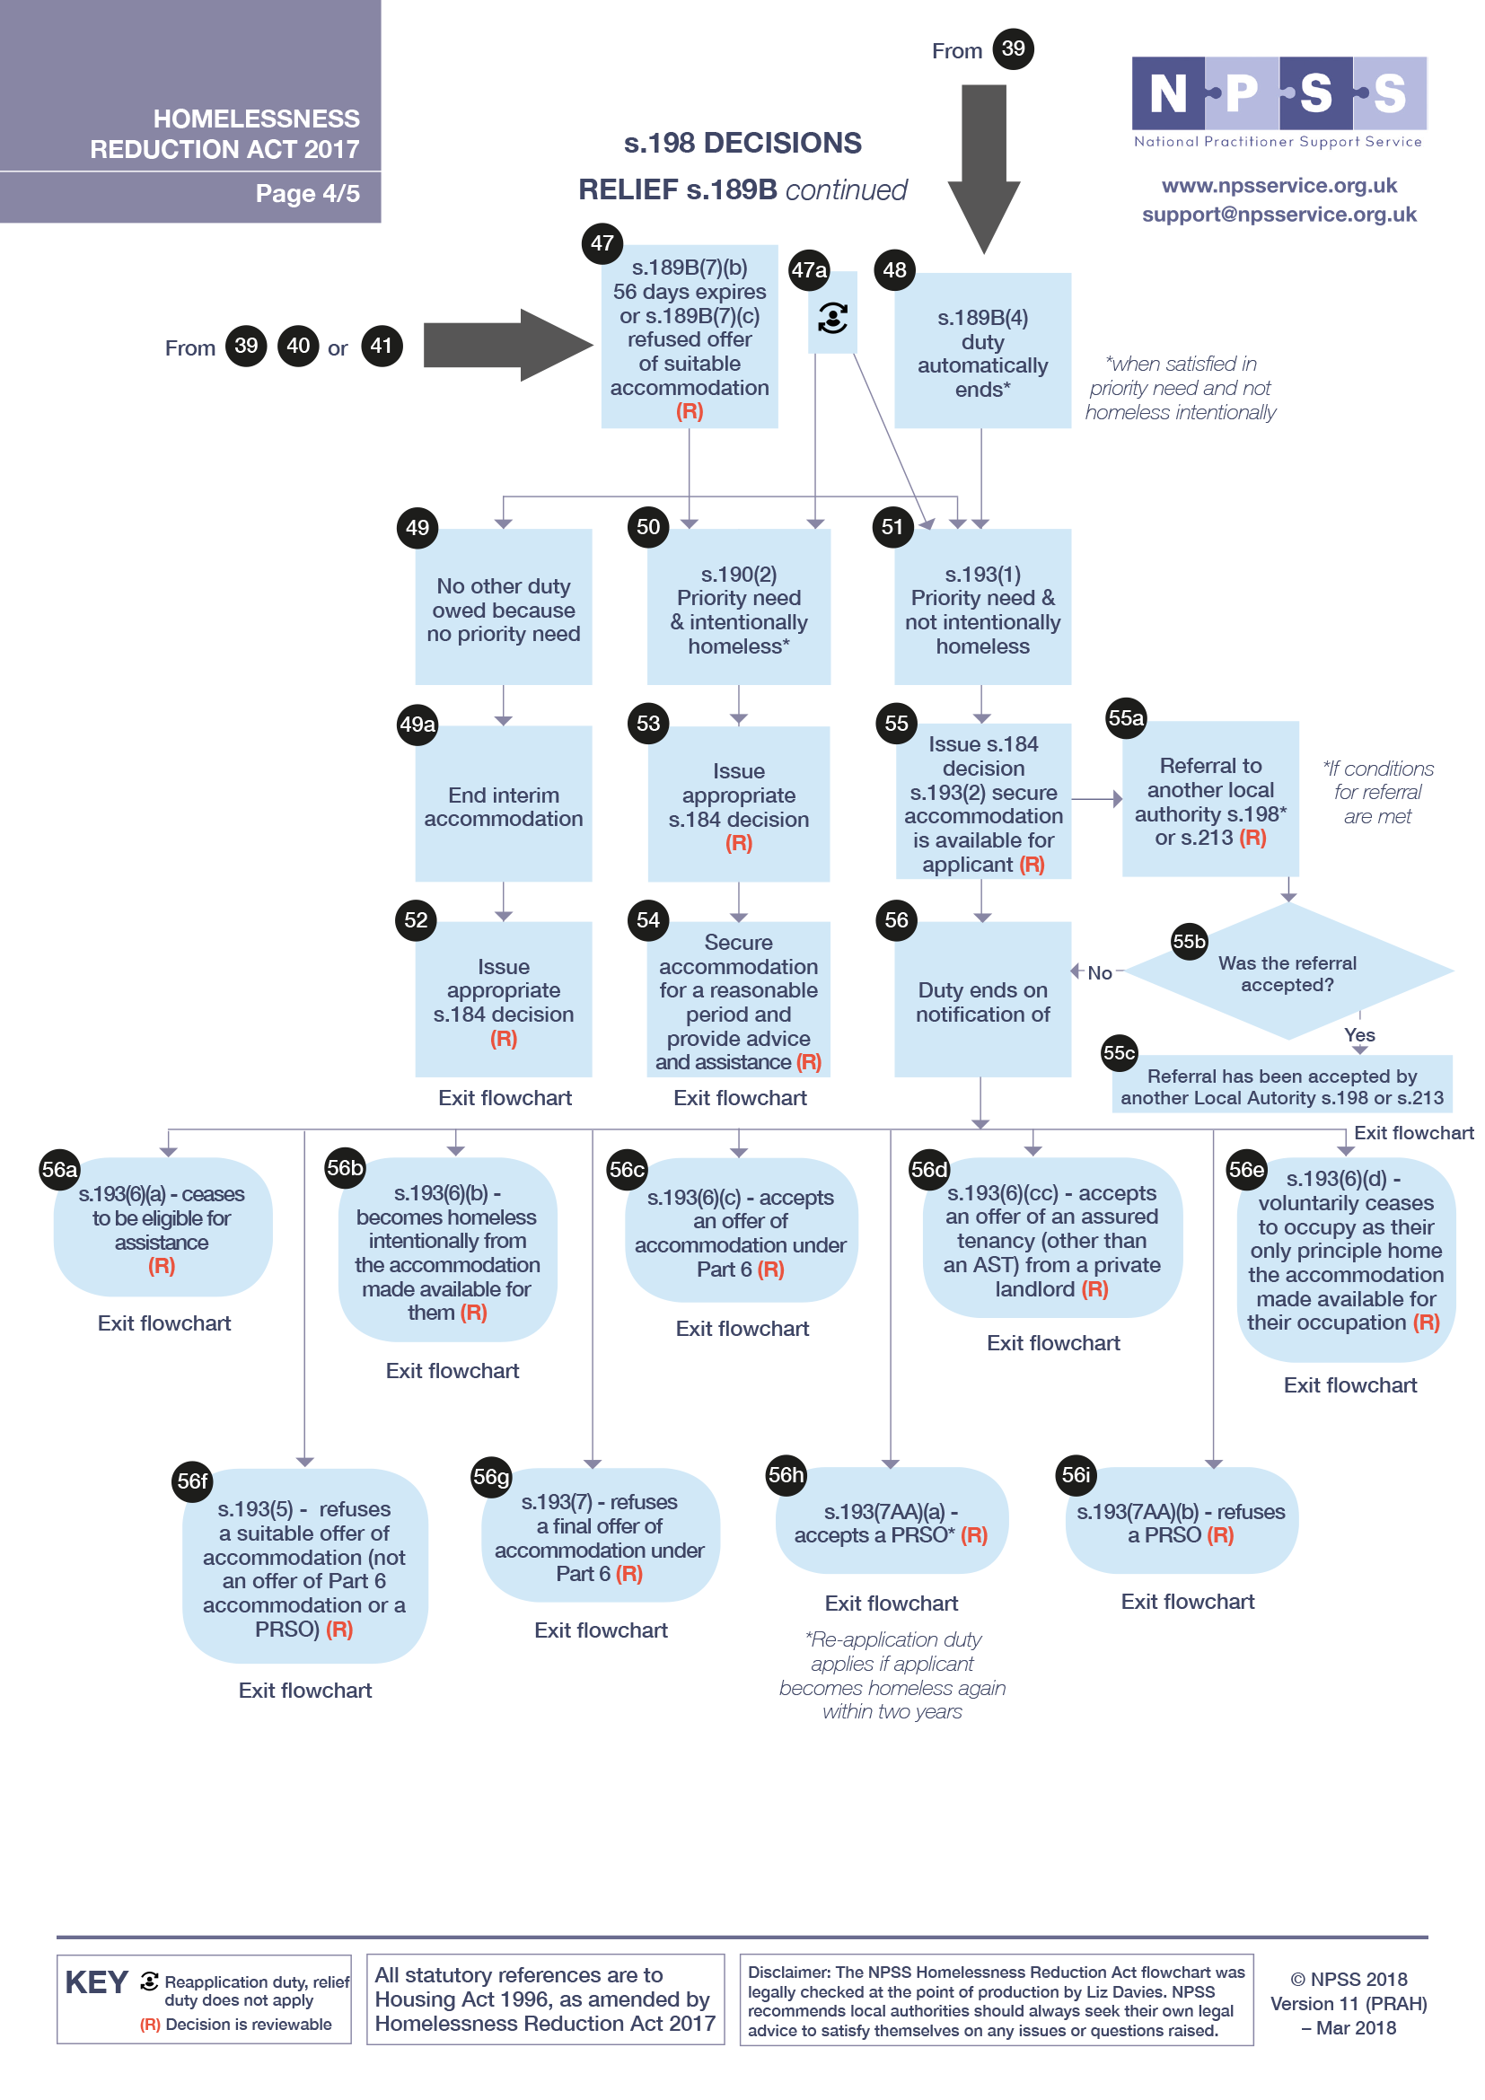

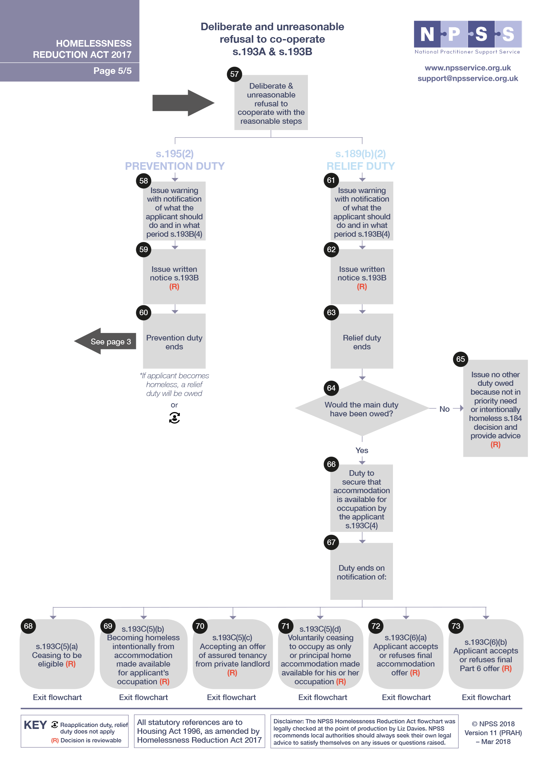

[Insert body text here]

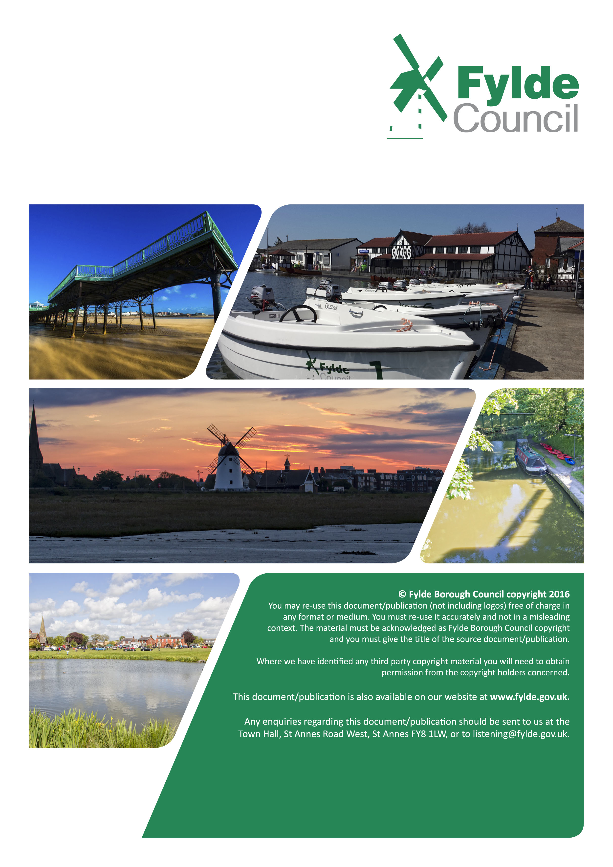

Date: Month / Year Review Date: Month / Year
Our Ref: XXXXXXXXX Authorised by: Insert Name and Position

